Second Sale Shopping

Madhuri Katakamsetty

# Database Design:

Category:

* 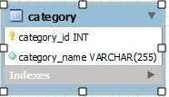Here the admin can add the categories by giving category_name this data is stored in category table.

# Sub category:

* + 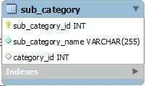Here the admin can add the subcategories based on categories so the sub_category_name and category_id Is foreign key this data is

stored in subcategory table.

# User:

* + - 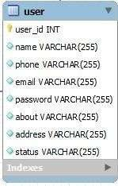The user acts like both seller and buyer when the

User click on register button the user can enter this Details name, email, phone, password, about,

Status this data is stored in user table.

# Product:

* + - 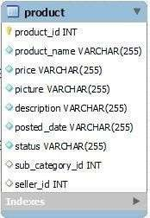The seller can add the product by giving Product_name, price, picture, description,

posted_date, status and subcategory_id and seller_id are the foreign keys this data is stored in Product table.

# Transaction:

* + - 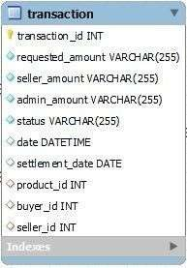When the user can buy the product then user pay the amount by giving requested_amount,

seller_amount , admin_amount, status, date Settelment_date, product_id, buyer_id and seller_id are foreign keys this data is stored in Transaction table.

# Database Screenshot:

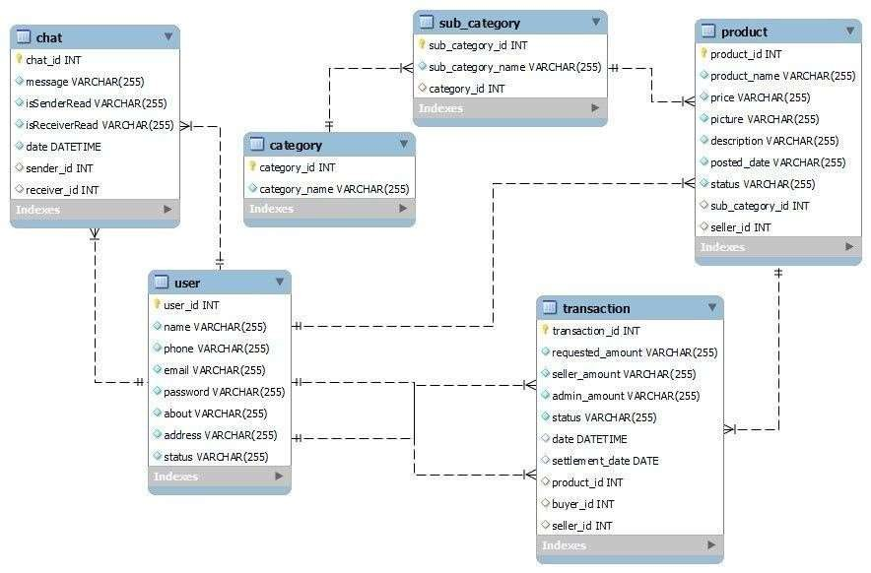

Backend Implementation:

Technologies:

Python Programming Language:

Python is very user friendly and easy to understand and these include variety of libraries like flask that which we used to create the server and also we use flask framework.

MySQL :

This is the technology we used to handle user details and login credentials and we created inserted data easily with these technology and we do the clear view of the data.

# Back End Screenshot:

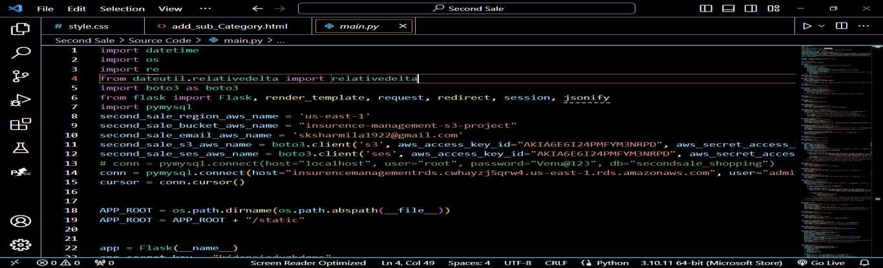

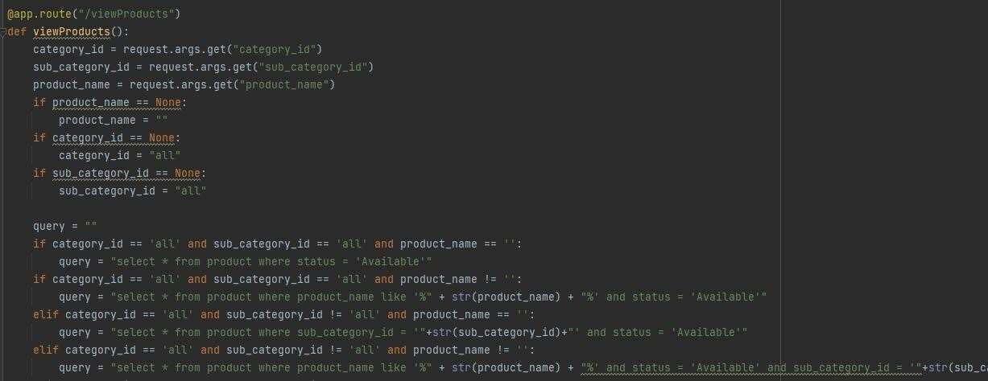

-

# Front End Implementation:

Technologies:

Bootstrap :

We used bootstrap to design html pages and we style various text and buttons using bootstrap .This made to design easy and simple way.

CSS :

we used css to style the web pages and make them to describe the web pages more elegant and detailed

manner.

HTML :

we used the html pages to create web pages it is fundamental technology to design any website.

JAVA SCRIPT :

it is the technology that makes to interact with webpages and helps to fetch and request the data and

operations.

# Front End Screenshots:

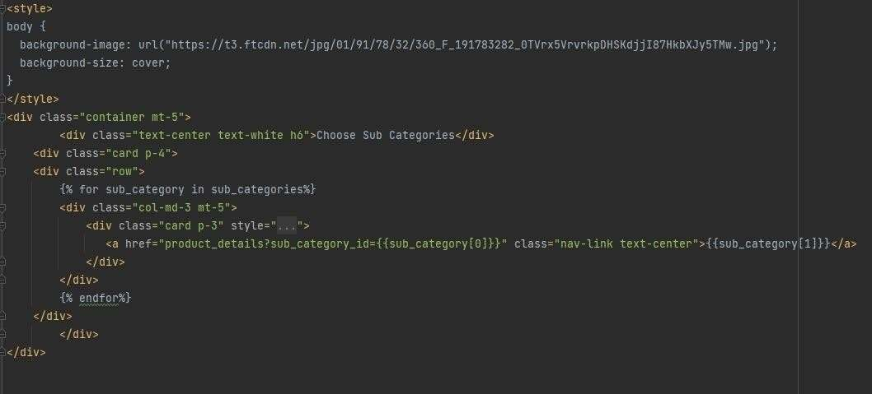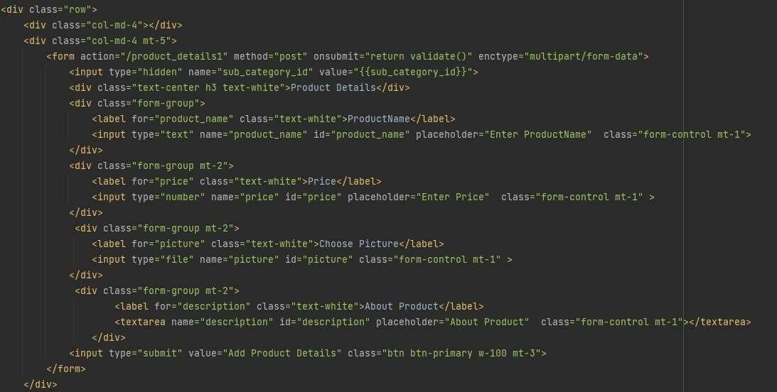

Project URL:

<http://3.138.155.237/>

